Vào HomeController:­­­­­­

public IActionResult SanPhamTheoLoai(string MaLoai, int? page)

{

// home/SanPhamTheoLoai?maloai=vali (tui, balo...)

int pageNumber = page == null || page < 1 ? 1 : page.Value;

int pageSize = 8;

var lstsanpham = csdl.TDanhMucSps.Where(x => x.MaLoai == MaLoai).OrderBy(x => x.TenSp);

PagedList<TDanhMucSp> lst = new PagedList<TDanhMucSp>(lstsanpham, pageNumber, pageSize);

ViewBag.maloai = MaLoai;

return View(lst);

}

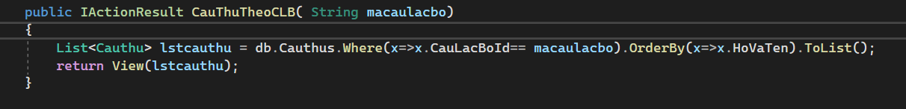

Add view -> Add Razor View:

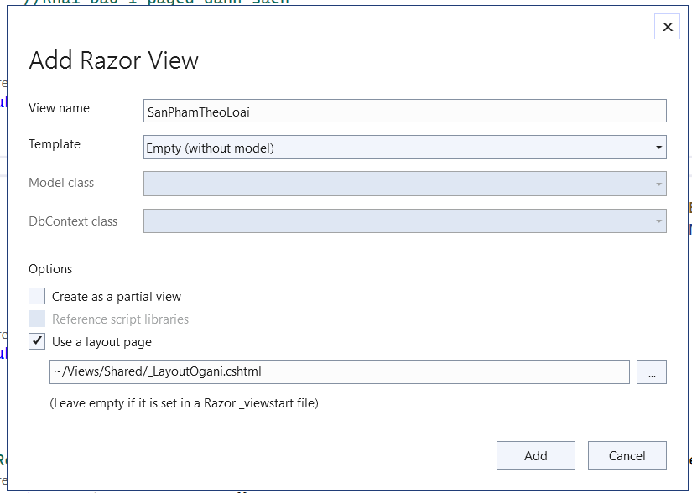

Giong trang index -> copy trang index sang

SanPhamTheoLoai.cshtml:

@{

ViewData["Title"] = "SanPhamTheoLoai";

Layout = "~/Views/Shared/_LayoutOgani.cshtml";

}

@using X.PagedList.Mvc.Core;

@model X.PagedList.IPagedList<TDanhMucSp>;

@foreach (var sanpham in Model)

{

<div class="col-lg-3 col-md-4 col-sm-6 mix oranges fresh-meat">

<div class="featured__item">

<div class="featured__item__pic set-bg" data-setbg="

@Url.Content("../Images/" + sanpham.AnhDaiDien)"

style="background-image: url(&quot;img/featured/feature-1.jpg&quot;);">

<ul class="featured__item__pic__hover">

<li><a href="#"><i class="fa fa-heart"></i></a></li>

<li><a href="#"><i class="fa fa-retweet"></i></a></li>

<li><a href="#"><i class="fa fa-shopping-cart"></i></a></li>

</ul>

</div>

<div class="featured__item__text">

<h6><a href="#">@sanpham.TenSp</a></h6>

<h5>@sanpham.GiaLonNhat</h5>

</div>

</div>

</div>

}

<div class="product__pagination">

@Html.PagedListPager(Model, page=>Url.Action("SanPhamTheoLoai", new {page=page, maloai=ViewBag.maloai}))

</div>

Vào file Default:

Cach 1:

Them asp-controller , ….

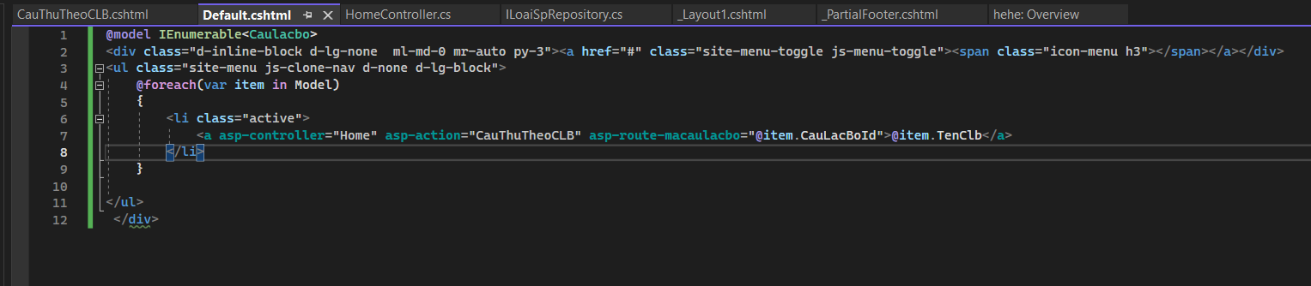

Cach2:

Thêm:

string loailink = "/home/sanphamtheoloai?maloai=" + item.MaLoai;

<li><a href="@loailink">@item.Loai</a></li>

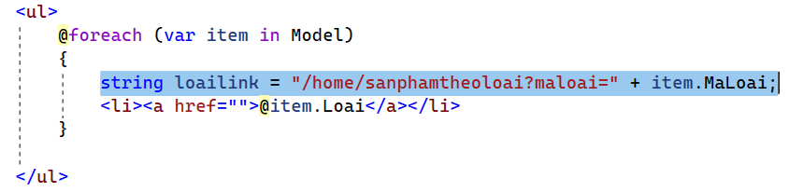

Tao Partial View de quan ly san pham theo loai cho de

Trong Shared them 1 Razor View:

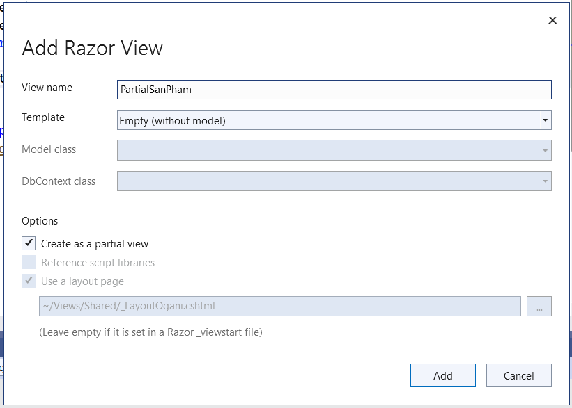

Them doan code:

@model TDanhMucSp

<div class="col-lg-3 col-md-4 col-sm-6 mix oranges fresh-meat">

<div class="featured__item">

<div class="featured__item__pic set-bg" data-setbg="

@Url.Content("../Images/" + Model.AnhDaiDien)"

style="background-image: url(&quot;img/featured/feature-1.jpg&quot;);">

<ul class="featured__item__pic__hover">

<li><a href="#"><i class="fa fa-heart"></i></a></li>

<li><a href="#"><i class="fa fa-retweet"></i></a></li>

<li><a href="#"><i class="fa fa-shopping-cart"></i></a></li>

</ul>

</div>

<div class="featured__item__text">

<h6><a href="#">@Model.TenSp</a></h6>

<h5>@Model.GiaLonNhat</h5>

</div>

</div>

</div>

Index:

@{

ViewData["Title"] = "Home Page";

Layout = "~/Views/Shared/_LayoutOgani.cshtml";

}

@using X.PagedList.Mvc.Core;

@model X.PagedList.IPagedList<TDanhMucSp>;

@foreach (var sanpham in Model)

{

@await Html.PartialAsync("PartialSanPham", sanpham)

}

<div class="product__pagination">

@Html.PagedListPager(Model, page=>Url.Action("Index", new {page=page}))

</div>

SanPhamTheoLoai.cshtml:

@{

ViewData["Title"] = "SanPhamTheoLoai";

Layout = "~/Views/Shared/_LayoutOgani.cshtml";

}

@using X.PagedList.Mvc.Core;

@model X.PagedList.IPagedList<TDanhMucSp>;

@foreach (var sanpham in Model)

{

@await Html.PartialAsync("PartialSanPham", sanpham)

}

<div class="product__pagination">

@Html.PagedListPager(Model, page=>Url.Action("SanPhamTheoLoai", new {page=page, maloai=ViewBag.maloai}))

</div>